Use Case Realisation Report (Analysis) - Print Certificate
FOR
Volunteer Management System
(VMS)

CLIENT
PROJECT | Volunteer Management System (VMS)Volunteer Management System
TITLE | Use Case Realisation Report (Analysis) - Print Certificate
VERSION | 0.3a0.2a
DATE | 14-Aug-2011
 | ORIGINATOR
 | Name / Signature | Team 8S
 | APPROVAL
 | Name / Signature | Phung Kim Cuong, Dio
Institute of Systems Science |  | Document Reference
25 Heng Mui Keng Terrence  Singapore 119615 |  | VMS/T-1.4.1/1

 | Acceptance
 | Customer Signature |  | Customer Signature
 | Name & Designation |  | Name & Designation
 | Date & Company Stamp |  | Date & Company Stamp

Revision History

Date | Version | Description | Author
12-Jun-2011 | 0.1a | Creation | Team 8S
11-Aug-2011 | 0.2a | Update | Team 8S
13-Aug-2011 | 0.3a | Update | Team 8S
 |  | Refer to amendment history

Table of Contents

1. Brief Description 3
2. Flow of Events 3
2.1 Standard Flow 3
2.2 Exceptions 3
3. Interaction Diagrams 4
3.1 Collaboration Diagram for Print Certificate 4
4. Participating Objects 4
4.1 Certificate 4
This entity object stores the details concerning a certificate of the volunteer. The primary attribute that it holds is the certificateID. 4
4.2 MainController 4
4.3 CertificateController 4
4.4 PrintCertificateScreen 4
4.5 HomeScreen 4
5. Class Diagrams 5
6. Derived Requirements 5
ANNEX D Amendment History 6

Use Case Realisation Report(Analysis) – Print Certificate

Brief Description
The use case enables the System Administrator to print certificate of a volunteer for the projects that he/she has participated in.

Flow of Events
The standard flow of events for this use case and any exceptions are described in the following subsections. See section 3.1 for an overview of the participating Actors and Domain Objects.

Standard Flow
Precondition: GenerateCertificate use case has been executed
This use case provides the user interface related functionality that will be provided to the System Administrator as follows:
- When the system administrator clicks ‘Print Certificate’ button, the method MainController .printCertificateScreen() is triggered.
- The MainController.printCertificateScreen() will use the method CertificateController.getCertificate() to get the certificate for the specified volunteer.
- CertificateController.getCertificate() will use the Certificate.getCertificateData() method to get Certificate data.
- The PrintCertificate screen will show, and get certificate data for printing.
- The use case terminates.

Exceptions
The following exceptions were identified:

Interaction Diagrams

Collaboration Diagram for Print Certificate
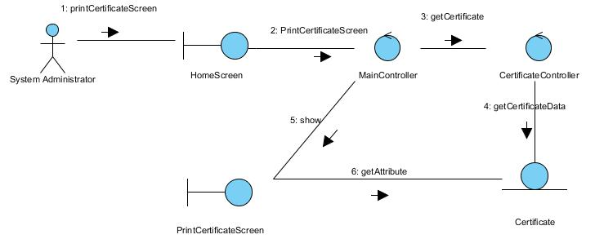

Figure 1 – Collaboration Diagram for Print Certificate

Participating Objects

Certificate

This entity object stores the details concerning a certificate of the volunteer. The primary attribute that it holds is the certificateID.

MainController
This controller object co-ordinates the menu selection and dispatches of requests of the volunteer management system. It delegates the user requests to the specific use case controller objects for carrying out the use cases.

CertificateController
This controler object co-ordinates the printing of the certificate in the volunteer management system. It receives requests from the boundary objects allocated for the specific purposes, along with all the necessary details required for the execution of these requests.

PrintCertificateScreen
This boundary object is used for retrieve the request of printing of certificate. The User actor uses this object.

HomeScreen
This boundary object is used for redirecting and displaying of home screen details and menu. All the user actors use this object.

Class Diagrams
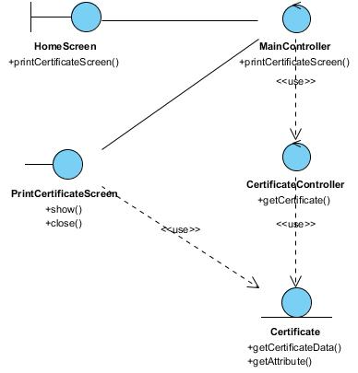

Figure 2 – Class Diagram

Derived Requirements

ANNEX D Amendment History

This is a record of all amendments made to the Document.
Version | Chapter / Section | Page No | Notes of Amendments or Changes

